- Memory addressing
Logical address: segment selector + offset
Linear/virtual address: unsigned integer used to express 4GB space.
Physical address: unsigned integer.

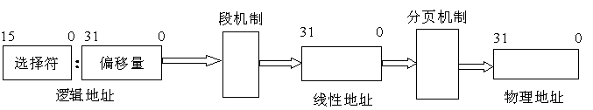

- Segment
- . Selector

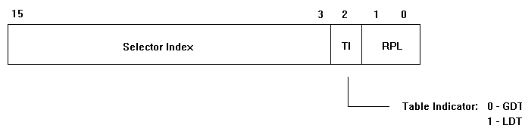

Kernel CS and DS selector: __KERNEL_CS __KERNEL_DS
USER CS and DS selector: __USER_CS __USER_DS

#define GDT_ENTRY_KERNEL_BASE (12)
#define GDT_ENTRY_KERNEL_CS (GDT_ENTRY_KERNEL_BASE+0)
#define GDT_ENTRY_KERNEL_DS (GDT_ENTRY_KERNEL_BASE+1)

#define __KERNEL_CS (GDT_ENTRY_KERNEL_CS*8)
#define __KERNEL_DS (GDT_ENTRY_KERNEL_DS*8)

#define GDT_ENTRY_DEFAULT_USER_CS 14
#define GDT_ENTRY_DEFAULT_USER_DS 15
#define __USER_DS (GDT_ENTRY_DEFAULT_USER_DS*8+3)
#define __USER_CS (GDT_ENTRY_DEFAULT_USER_CS*8+3)

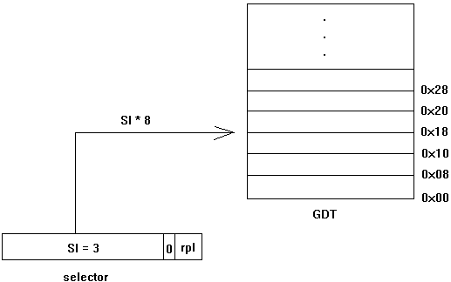

- Descriptor

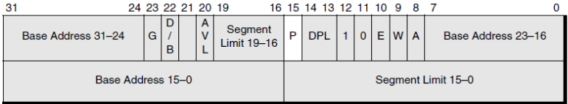

Each segment descriptor stores in the GDT or LDT
GDT: Global Descriptor Table,
LDT: Local Descriptor Table

struct desc_struct {
union {
struct {
unsigned int a;
unsigned int b;
};
struct {
u16 limit0;
u16 base0;
unsigned base1: 8, type: 4, s: 1, dpl: 2, p: 1;
unsigned limit: 4, avl: 1, l: 1, d: 1, g: 1, base2: 8;
};
};
} __attribute__((packed));

struct gdt_page {
struct desc_struct gdt[GDT_ENTRIES];
} __attribute__((aligned(PAGE_SIZE)));
/*all the base is 0 in linux*/
DEFINE_PER_CPU_PAGE_ALIGNED(struct gdt_page, gdt_page) = { .gdt = {
[GDT_ENTRY_KERNEL_CS] = GDT_ENTRY_INIT(0xc09a, 0, 0xfffff),
[GDT_ENTRY_KERNEL_DS] = GDT_ENTRY_INIT(0xc092, 0, 0xfffff),
[GDT_ENTRY_DEFAULT_USER_CS] = GDT_ENTRY_INIT(0xc0fa, 0, 0xfffff),
[GDT_ENTRY_DEFAULT_USER_DS] = GDT_ENTRY_INIT(0xc0f2, 0, 0xfffff),
} };

Logical address: segment selector + offset
Linear/virtual address: unsigned integer used to express 4GB space.
In linux:
Linear/virtual address = base of descriptor + offset
Linear/virtual address = offset

Segment puts the process into different virtual address space
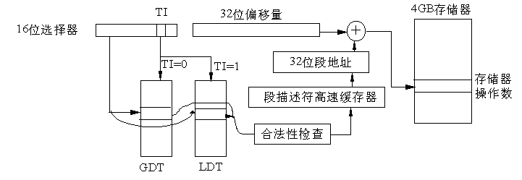

- Paging
PGD PUD PMD PTE OFFSET
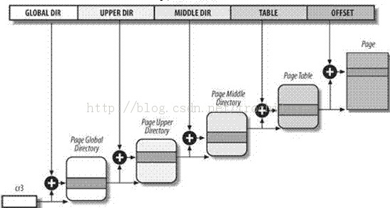
X86_32:
PAE disable，OFFSET is 12bit，TABLE is 10bit，PMD is 0bit, PUD is 0bit, PGD is10bit
PAGE_SHIFT = 12; PMD_SHIFT = 22; PUD_SHIFT = 22; PGD_SHIFT = 22;
Page descriptor:
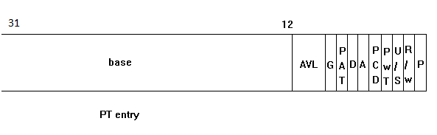
typedef unsigned long pteval_t;
typedef union {
pteval_t pte;
pteval_t pte_low;
} pte_t

PAE enable，OFFSET is 12bit, TABLE is 9bit，PMD is 9bit，PUD is 0bit，PGD is 2bit.
PAGE_SHIFT = 12; PMD_SHIFT = 21; PUD_SHIFT = 30; PGD_SHIFT = 30;
Page descriptor:
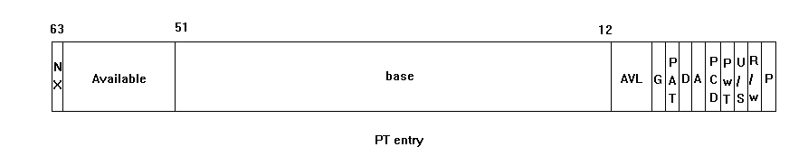
typedef u64 pteval_t;
typedef union {
struct {
unsigned long pte_low, pte_high;
};
pteval_t pte;
} pte_t;

X86_64:
OFFSET is 12bit，TABLE is 9bit，PMD is 9bit, PUD is 9bit, PGD is 9bit
PAGE_SHIFT = 12; PMD_SHIFT = 21 PUD_SHIFT = 30 PGD_SHIFT = 39;
Page descriptor:
typedef struct { pteval_t pte; } pte_t;
typedef unsigned long pteval_t;

XXX_MASK = ~(1 << XXX_SHIFT - 1)
PTRS_PER_XXX = pow(2, n); n is the bit size of the XXX

Translate virtual address to physical page:
pgd = pgd_offset(current->mm, vaddr);
if ( pgd_none(*pgd) || pgd_bad(*pgd) )
{
printk("invalid pgd\n");
retval = -1;
goto error;
}

pud = pud_offset(pgd, vaddr);
if ( pud_none(*pud) || pud_bad(*pud) )
{
printk("invalid pud\n");
retval = -1;
goto error;
}

pmd = pmd_offset(pud, vaddr);
if ( pmd_none(*pmd) || pmd_bad(*pmd) )
{
printk("invalid pmd\n");
retval = -1;
goto error;
}
printk("before pte_offset_map\n");

pte = pte_offset_map(pmd, vaddr);

printk("after pte_offset_map\n");
pte_unmap(pte);
if ( pte_none(*pte) )
{
printk("bad pte va: %lX pte: %p pteval: %lX\n", vaddr, pte, pte_val(*pte));
retval = -1;
goto error;
}

page = pte_page(*pte);
phy_addr = (unsigned long)(page - mem_map) << PAGE_SHIFT;

